Experiment:-8
Problem Statement:-
Create a simulation to demonstrate logical addressing using IPv4 and IPv6. Implement address mapping techniques such as ARP, RARP, BOOTP, and DHCP to show how devices acquire and resolve network addresses. Use Cisco Packet Tracer to visualize and analyze these address resolution processes.

Aim:- Simulation of Logical Addressing using IPv4 and IPv6
Procedure:-

PART 1: Setup Network Topology

Step 1: Add All Devices
- Open Cisco Packet Tracer
- Add these devices to workspace:
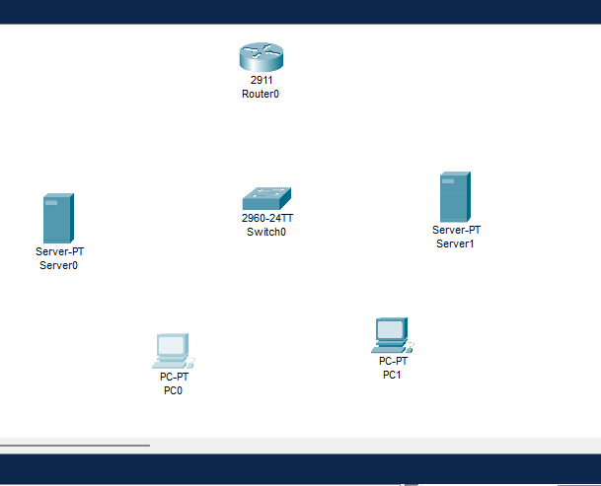

Step 2: Connect All Devices
Use Straight-Through Copper Cable for all connections:
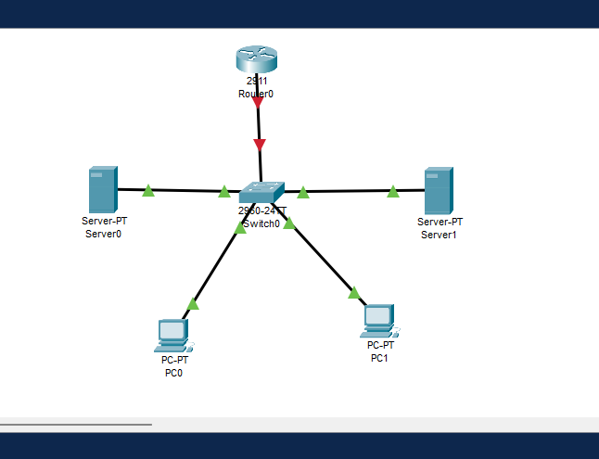

PART 2: Configure IP Addresses (IPv4 + IPv6)

Step 3: Configure Router Interface
- Double-click Router
- Go to CLI tab
- Type these commands:
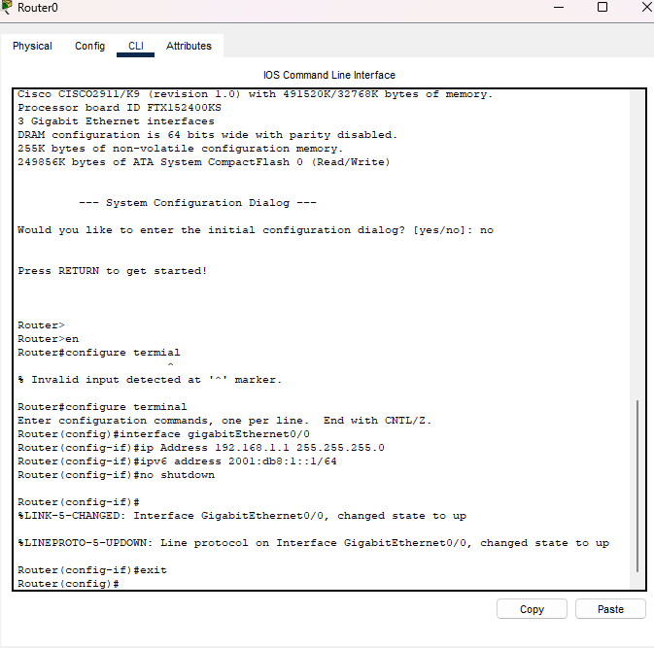

Step 4: Assign Static IP to PC0
- Double-click PC0
- Go to Desktop → IP Configuration
- Enter:
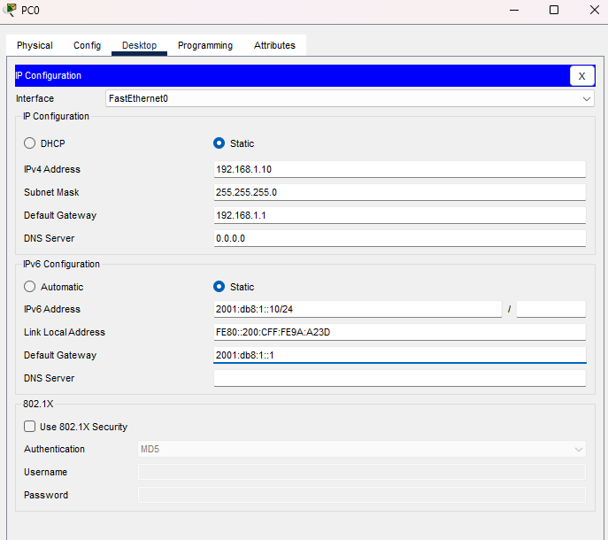
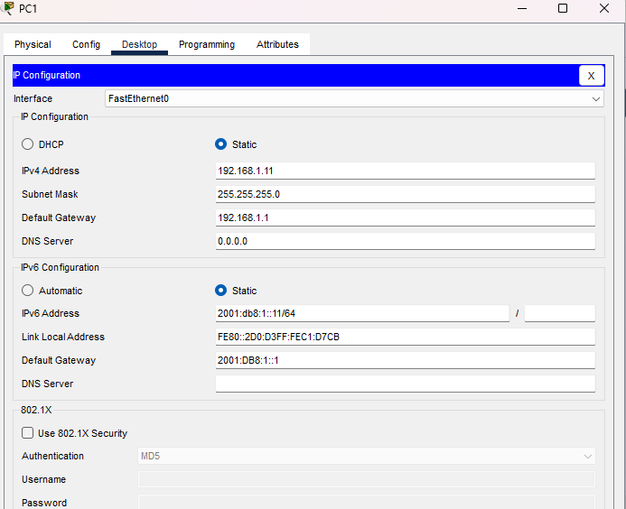

Step 6: Assign IP to DHCP Server
- Double-click DHCP Server
- Go to Desktop → IP Configuration
- Enter:

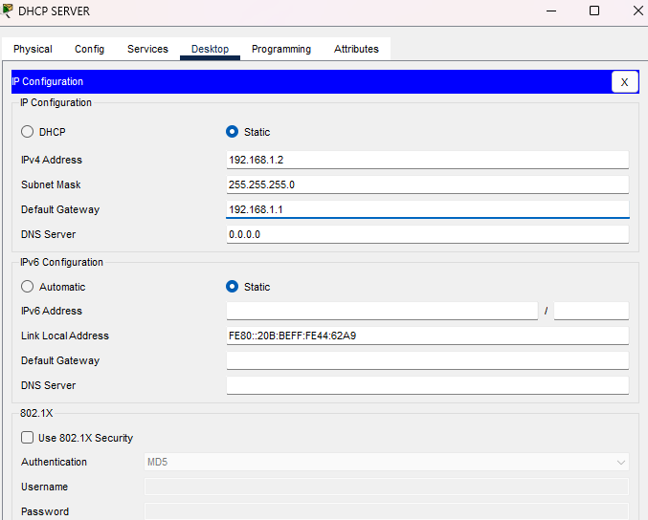
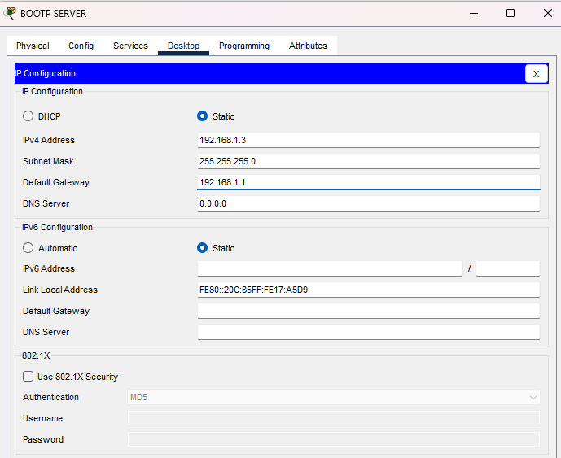

PART 3: Configure ARP

Step 8: Simulate ARP Request
- Double-click PC0
- Go to Desktop → Command Prompt
- Type:
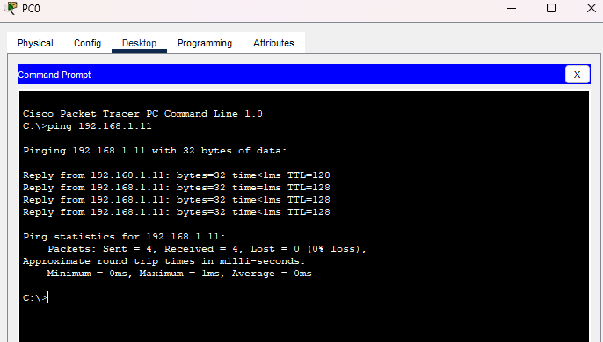

Step 9: View ARP Table
After ping, type in PC0 Command Prompt:
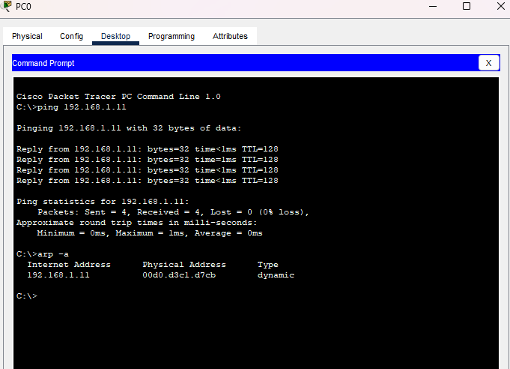
PART 4: Configure RARP

Step 10: Simulate RARP Concept
- Double-click BOOTP Server
- Go to Services tab
- Click DHCP service
- Add a static mapping entry:
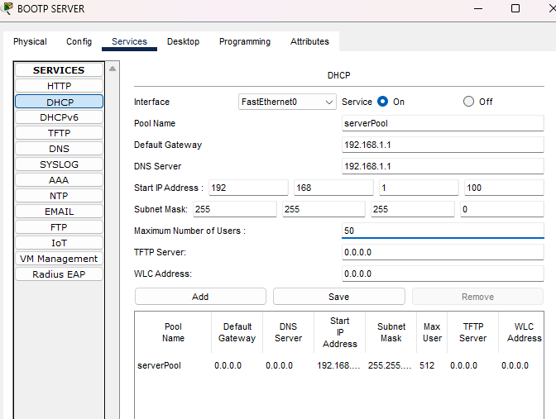

Step 11: Find PC0's MAC Address
- Double-click PC0
- Go to Desktop → Command Prompt
- Type:

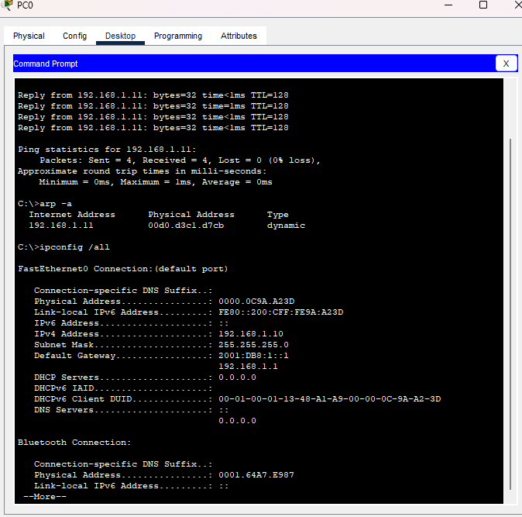
Step 12: Add Note for RARP on Workspace
RARP (Reverse ARP):
- Device sends its MAC address
- Server responds with IP address
- Legacy protocol replaced by BOOTP/DHCP
- Simulated here using static DHCP mapping

Step 14: Test BOOTP on PC0
- Double-click PC0
- Go to Desktop → IP Configuration
- Select DHCP radio button
- PC0 will send a BOOTP/DHCP Discover broadcast
- Server responds with an IP address
- You'll see IP auto-assigned ✅
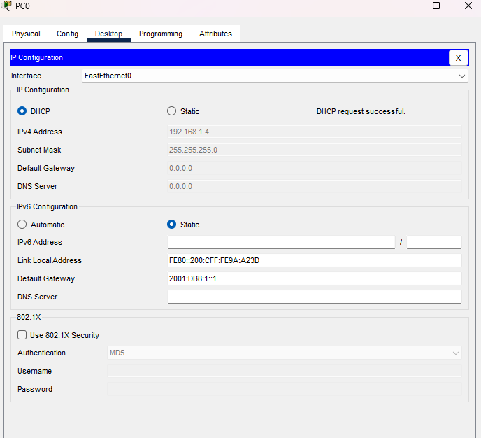

ART 6: Configure DHCP Server

Step 15: Enable DHCP Service
- Double-click DHCP Server
- Go to Services tab
- Click DHCP
- Configure the pool:
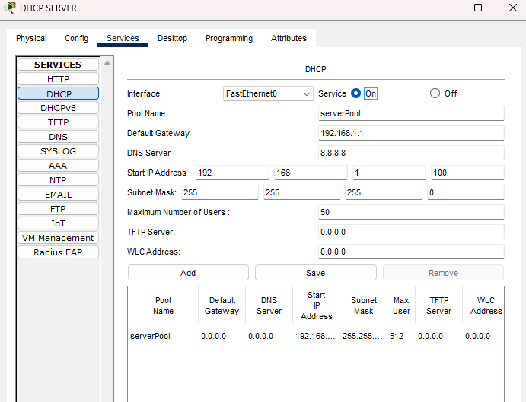

Step 16: Test DHCP on PC1
- Double-click PC1
- Go to Desktop → IP Configuration
- Click DHCP radio button
- Wait 5–10 seconds
- PC1 will receive:

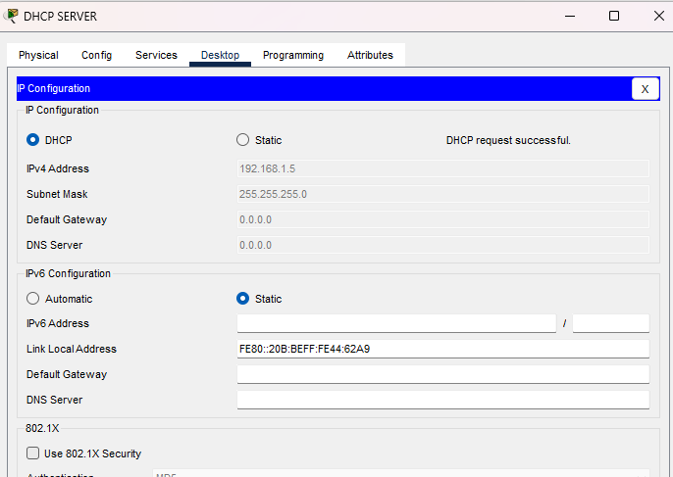
PART 7: Test IPv4 and IPv6 Communication

Step 17: IPv4 Ping Test
On PC0 Command Prompt:
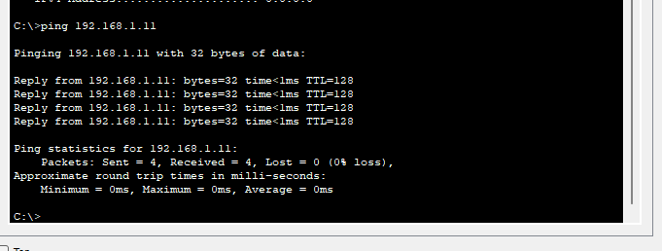

Step 18: IPv6 Ping Test
On PC0 Command Prompt:
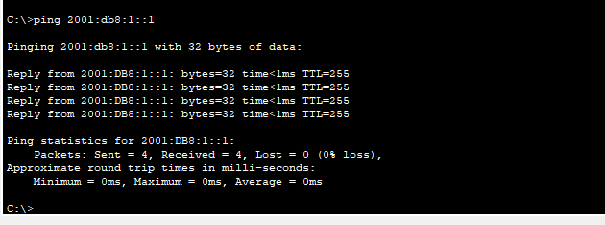
Step 19: Ping the Router
